

Bilkent University

Department of Computer Engineering

Group: 10-1

Section: 1

17.12.2023

**CS 319 Term Project**

**BilMart: Connecting the Bilkent Community**

Final Report

**Group members:**

Berk Özkan - 22001293

Mert Fidan - 22101734

Emir Kerem Şahin - 22101882

Maryam Azimli - 22101528

Umut Arda Tuncar - 22103593

Table of Contents

**1. Introduction 3**

**2. Lessons Learned & Experience 3**

**3. User’s Guide 4**

3.1. Login and Sign Up 4

3.2 Home Page and View Items 4

3.3 Classification Bar 5

3.4 Navigate Panel 5

3.5 Profile Page 5

3.6 Create a Post 5

3.7 Edit a Post 6

3.8 Wishlist Page 6

**4. Build Instructions 6**

**5. Work Allocations 7**

Maryam Azimli - 22101528 7

Berk Özkan - 22001293 8

Mert Fidan - 22101734 10

Umut 11

Emir Kerem Şahin - 22101882 11

**6. What we did, did not, and why? 12**

**7. Appendix 12**

A. Log in page 12

B. Sign up 13

C. Verification page 14

D. Home page 14

E. View sale item with more than one picture 15

F. View Donation Item 16

G. View Borrowal item 16

H. View Lost item 17

I. Classification bar 17

J. Navigate panel 18

K. About page 18

L. profile page 19

M. Edit profile 19

N. Create a post 20

O. Edit Post 21

P. Wishlist page 21

# Introduction

Bilmart is a special website that is quite simple to handle and has great and sophisticated features. The community's second hand sales, lend/borrow postings, donations, and lost/found items are all coordinated through BilMart. Bilmart's platform is designed to take care of the wide range of needs of the Bilkent community. With user-friendly features like wishlists and email notifications, BilMart is easy to navigate. Users can monitor their interests with the help of the wishlist function, and timely updates will be delivered by email alerts.

Additional features like sorting through posts and advanced search options that allow authorized users to search posts with the same title, description, and tags improve the user experience even more. Another thing we tried to implement was not allowing unauthorized users to access posts, profiles, or wishlist features of the site.

While implementing our original plans, it was difficult to optimize email delivery, create strong authentication, and send emails. But we were able to do that after extensive work. We were not able to create a rating system for the users, though.

# Lessons Learned & Experience

At the beginning of the project, most of us did not have prior knowledge of the MERN stack (node.js + express.js + react.js + mongoDB). We all needed to adapt and learn, as extensive time had to be spent first on understanding and later on implementing.

However, before the implementation phase, we had to consider analysis and design steps. In the analysis step, our group divided the UML diagrams, and this helped us see how each of us understood the assignment. By learning from our mistakes, we completed this stage successfully. We all shared our opinions on each other's diagrams and suggested better ways to do them. This also somewhat helped us to prepare for the midterms.

In the design step, we were more or less ready for the challenges as we had more knowledge of what we were expected to do. In this step, we learned about subsystems, how to use them, and what they are for. We had to spend a great amount of time redoing our class diagram at this stage.

Finally, in the implementation stage, we all tried to contribute and make our website look enhanced. We had to meet much more during this stage to make decisions, merge some branches, make changes, etc.

# User’s Guide

## 3.1. Login and Sign Up

Our website, like most sites, starts with the login page. While the user is not logged in, he or she cannot access the navigation bar’s features, such as home, wishlist, and profile. If the user does not have an account yet, they can click on the sign-up feature, which requires a Bilkent email address, username, title at Bilkent University (undergraduate student, instructor, etc.), and password. The user must enter a valid Bilkent mail, a password that contains at least 8 characters, of which a number, an upper-case, a lower-case, and a special character must be present. After filling out these fields correctly, the user is redirected to the verification page, where he or she is required to input the verification code sent to their email address. After verifying, the user is sent back to the login page, where he or she is required to enter an email address and password. After successful login, the user is redirected to the home page. See Appendices A, B, and C for login, sign-in, and verification pages.

## 3.2 Home Page and View Items

On the home page, the user is met with a list of posts that have a picture, title, price, category, and short description shown. If the user wants more information, he or she can click on “View” for any post and view the post on the bigger screen with additional information about the seller, a function to add the item to the wishlist, a function to report a post, and tags.

Other than the list of items, the user can click on the wishlist, profile, about, and home pages from the navigation bar. On the left side of the home page, there is a classification bar. See Appendices D through H.

## 3.3 Classification Bar

The purpose of the classification bar is to assist the user with searching and/or sorting through posts by showing the posts they desire. The features within the classification bar are: selection of category tags; selection of category for the item they are looking for, such as sale, lend, donation, or lost and found item; below that is a search engine that helps when the user has something specific in mind. Our search engine will show posts with matching titles, descriptions, or tags. For searching with several tags, the user can simply separate the tags by comma-space. Below are pictures of the classification bar and some search results. See Appendix I.

## 3.4 Navigate Panel

Our navigation panel can help us access profile, home, about, wishlist, and settings pages. When clicking on settings, we are given additional functionalities such as editing profiles and/or logging out of the site. See Appendices J and K.

## 3.5 Profile Page

Our profile page shows our username, the number of posts we have created, and the list of posts we have created. We can view, edit, or delete the items we have created here. Additionally, we are creating new posts here too. If we edit a post, users who have wishlisted the item will be notified of changes through their emails. See Appendices L and M.

## 3.6 Create a Post

While creating a post, there are required fields to fill, otherwise, the user will not be able to create the post. The required fields are title, description, tags, and then the selection of a category of the item such as lend, lost and found, sale, or donation. After clicking the respective button, the user will get additional fields for some of the categories. For example, in a borrow/lend and sale, there is a price field. For the donation, there is a monetary goal field, etc. We also have a feature to include pictures for the post. It is mandatory to upload between 1-5 pictures while creating a post. See Appendix N.

## 3.7 Edit a Post

The user is allowed to edit the title, description, type, and pictures of the post. Also, type specifications such as listing price and monetary goal can be edited. Users who have wishlisted the item will be notified of changes via email. See Appendix O.

## 3.8 Wishlist Page

The list of items the user has wishlisted is shown here. The user can view the number of listings he/she wishlisted and the user information in the section on the left. The user can also create a new listing from the user information section by clicking “New Post.”. See Appendix P.

# Build Instructions

1. You need to install node.js from [here](https://nodejs.org/en/download).
2. You should have a working IDE. In case you already do not have it, here are two links: [Visual Studio Code](https://code.visualstudio.com/download) and [IntelliJ IDEA](https://www.jetbrains.com/idea/download/?section=windows).
3. You need to clone/fork the [repository](https://github.com/hkeremh/BilMart.git).
4. If you have Visual Studio code, you can directly click on Clone git repository. If you do not have Visual Studio Code, you should download git desktop and access the repository from there. After successfully cloning the repository, you can open the file in your IDE in the folder where you cloned it.
5. After opening the folder in the IDE, you need to make sure you are in the main branch.
6. You will need to open two terminals. In the first one, you need to make sure you are in the ‘Bilmart MVC’ directory by writing this line: **cd ‘Bilmart MVC’**. then you will run this line to download required modules: **npm i**.

In the second terminal, you will need to again open the ‘Bilmart MVC’ directory by writing: **cd ‘Bilmart MVC’** . Then, open the view directory by writing this line: **cd view**. Inside the view folder, you will need to install node modules here too. For this purpose, on the view directory, run: **npm i**.

1. After installing the necessary node modules, you will need to run the following line in the first terminal where you opened the ‘Bilmart MVC’ directory: **node index.js**. This will start the server of the application on port 400, using Express.js .
2. And then in the second terminal where you directed to ‘Bilmart MVC/view’, run: **npm start**. This will run the React app, which is the client-side of the application.
3. Running npm start in ‘Bilmart MVC/view’ will automatically open this website: <http://localhost:3000>.
4. You have successfully accessed the website.
5. To terminate, you will need to run **CTRL+C** in both shells if you are using Windows and **CMD+C** if you are using Mac.

# 

# Work Allocations

## **Maryam Azimli - 22101528**

Analysis Stage:

* Created Activity Diagrams
* Wrote tech stack
* Wrote half of the textual descriptions

Design Stage:

* Helped write an explanation for design goals
* Wrote an explanation for the adapter pattern.

Implementation Stage:

* Added tags to the create post from the front end in the create post
* Stored the tags in the form of an array in the database
* Combined tags from the posts and other collection
* Accessed and added tags to view item
* Fixed search so that it can search for the tags
* Fixed search so that it can access titles and descriptions
* Fixed search so that it can show a list with selected categories
* Fixed listing Model in order to access tags within posts
* Fixed listing Model in order to access tags selected by the user
* Fixed sorting and choosing lost&found items
* Created selecting tags by checkboxes
* Fixed searching by status
* Fixed sort by
* Created filtered search that shows a list of all items with categorizations added by the user
* Testing and reporting errors

Final Stage:

* Wrote the introduction
* Wrote the lessons learned & experience
* Wrote User’s guide
* Wrote Build Instructions
* Wrote the work allocation for myself
* Wrote the appendices

## 

## **Berk Özkan - 22001293**

Analysis Stage:

* Drew Class diagrams
* Reviewed all other diagrams
* Wrote constraints
* Wrote quality requirements

Design Stage:

* Designed final Class diagram
* Outlined DB structure (files titled “DB_JSON_…”)

Implementation Stage:

* Designed and Implemented:
  + Donation Class
  + Lend Item Class
  + Lost Found Class
  + Post Class
  + Post Strategy Class
  + Proxy Post Class
  + Temp User Class
  + Transactional Item Class
  + User Class
* Implemented Post Class as strategy pattern
* Implemented Class side of image proxy pattern
* Implemented adapter pattern in all classes as toJSON, allowing objects to be saved to the Mongo database.
* Added addToWishlist functionality to User Model.
* Implemented send notification in Listing Controller used to send notifications to a user when their wish-listed post has been edited/updated
* Contributed to several other routes in Listing Controller, restructured input for changing posts to match Post Class structure and added checks
* Added notification sending methods to Mail Controller for notifications
* Added wish-list functionality to User Controller to allow sending notifications from posts and wishlisted items
* Added request contact functionality to User Controller to send a notification to poster about interested parties
* Further added corner case checks to User Controller
* Added contact request functionality to User Model
* Contributed to styling in the front end
* Expanded upon Edit Profile page
* Added request item to frontend
* Added wish-list frontend components (especially edge case checks)
* Added card.css and general.css
* Added input checks for creating a post, for example only be able to input numbers to price
* Added DNS checking to weblinks for donations
* Implemented observer design pattern for notifications

Final Stage:

* Contributed to final report by writing own work
* Took screenshots for report and video
* Populated data for final presentation

## **Mert Fidan - 22101734**

Analysis Stage:

* Created the mockup pages in Figma
* According to the constraints, decided the design scope of the project

Design Stage:

* Designed the layout of all pages
* Designed the interactions between pages

Implementation Stage:

* Initiated the data transfer between database, server-side and client-side .
* Implemented the React codes for all of the files inside the client-side of the application. These files are:
  + About.jsx (About page for BilMart).
  + Card.jsx (Item cards that show the shortened information of listings).
  + ChangePassword.jsx (The page for updating a forgotten password).
  + CreateListing.jsx (The page for creating a listing).
  + EditListing.jsx (The page for editing a listing).
  + ForgotPassword.jsx (The page where the user enters his/her mail address to receive a mail for verifying his/her access to ChangePassword page).
  + Home.jsx (The homepage where all the listings are shown).
  + Item.jsx (The page where an individual item is shown in detail).
  + Login.jsx (The login page).
  + SignUp.jsx (The signup page).
  + Verify.jsx (The page where the user enters received verification code(through mail) to end sign-up process and start using BilMart)
  + LogoBar.jsx (A bar that contains BilMart’s logo).
  + NavBar.jsx (The navigation bar that contains links to Home, About, Wishlist, Settings and Profile).
  + Profile.jsx (The page where the users’ information and uploaded posts are shown. A user can create a post from this page).
  + Wishlist.jsx (The page where the users’ information and their wishlisted posts are shown. A user can create a post from this page).
* Updated the CSS code for styling the pages with Berk.
* Added reportPost functionality in both frontend and backend.
* Added addToWishlist functionality in frontend (finalized by Berk).

Final Stage:

* Tested the application to find and fix the bugs with the rest of the team.
* Contributed to the final report by writing my own work.
* Finalized the information shown on the About page for BilMart.

## 

## **Umut Arda Tuncar - 22103593**

Analysis Stage:

* Analyzed the use cases for the project
* Came up with more detailed scenarios to design sequence diagrams

Design Stage:

* Designed the sequence diagrams for:
  + Borrowing process
  + Buying process
  + Selling process
  + Lost&Found processes
  + Signup/login processes
  + Creating a post
  + Creating a user
  + Editing user profile
  + Handling the settings of the user
  + Main activity diagram that connects all processes

Implementation Stage:

* Implemented the searching algorithm for posts
* Added the tags to the database
* Enabled tags to be fetched from the database
* Added the classification section to the left part of the home page

Final Stage:

* Made editing of promo video

## 

## **Emir Kerem Şahin - 22101882**

Analysis Stage:

* Created state diagrams
* Created the use case diagram with the input off everybody in the team
* Wrote textual descriptions

Design Stage:

* Designed the final version of the class diagram that uses design patterns
* Wrote descriptions for the design patterns

Implementation Stage:

* Implemented an authentication system for the user to sign up and log in.
* Implemented a notification controller that sends email notifications to users.
* Implemented the proxy design pattern to make the website faster.
* Added image compression to make sure added images aren’t too large.
* Added lots of defensive programming to the back end to account for corner cases.
* Added a password strength checker to the back-end and front-end
* Fixed some UI bugs.

Final Stage:

* Wrote my part of work allocation
* Wrote the prerequisite part of the build instructions and added the build instructions to the README.md file
* Wrote the what we did, did not, and why
* Updated the build instructions in the report

# What we did, did not, and why?

* We are currently storing images in the database by their base64 strings, which is inefficient in terms of space allocation. In the future, it will be better to store images in the cloud and store their link urls in the database.
* We didn't add a rating feature for the sellers, because we believe that this functionality would misguide the users as it may be abused.
* We did not add a feature to communicate through the app, as users may not find it useful to communicate through our website. We believe that users would rather communicate through exchanging their numbers, which is why we added an option to add phone numbers to user profiles and control its publicity. When a user is interested in a listing, an email containing the necessary contact information is sent to the post owner, according to the publicity of the phone number of the interested user.

# Appendix

## A. Log in page

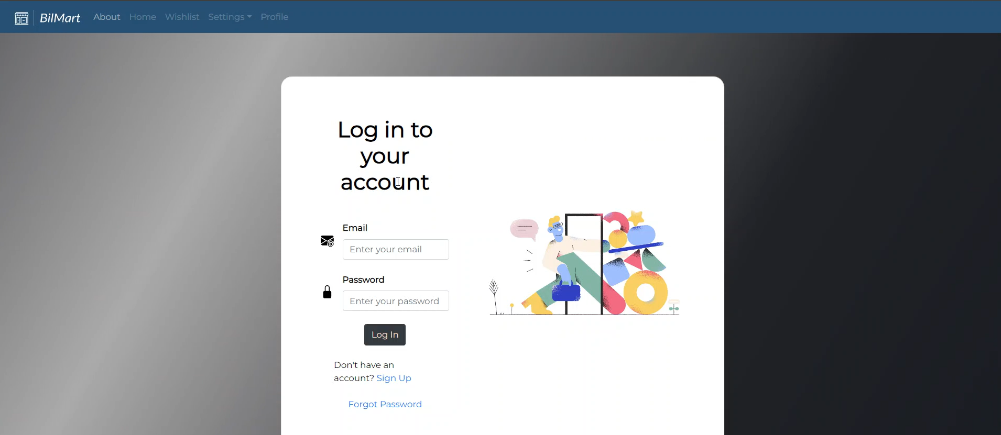

## B. Sign up

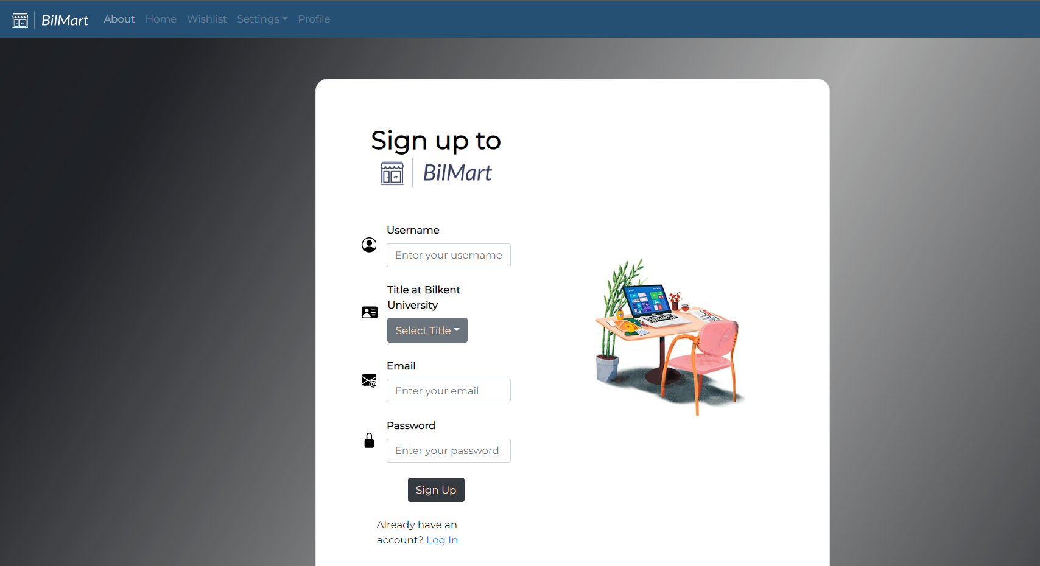

## 

## C. Verification page

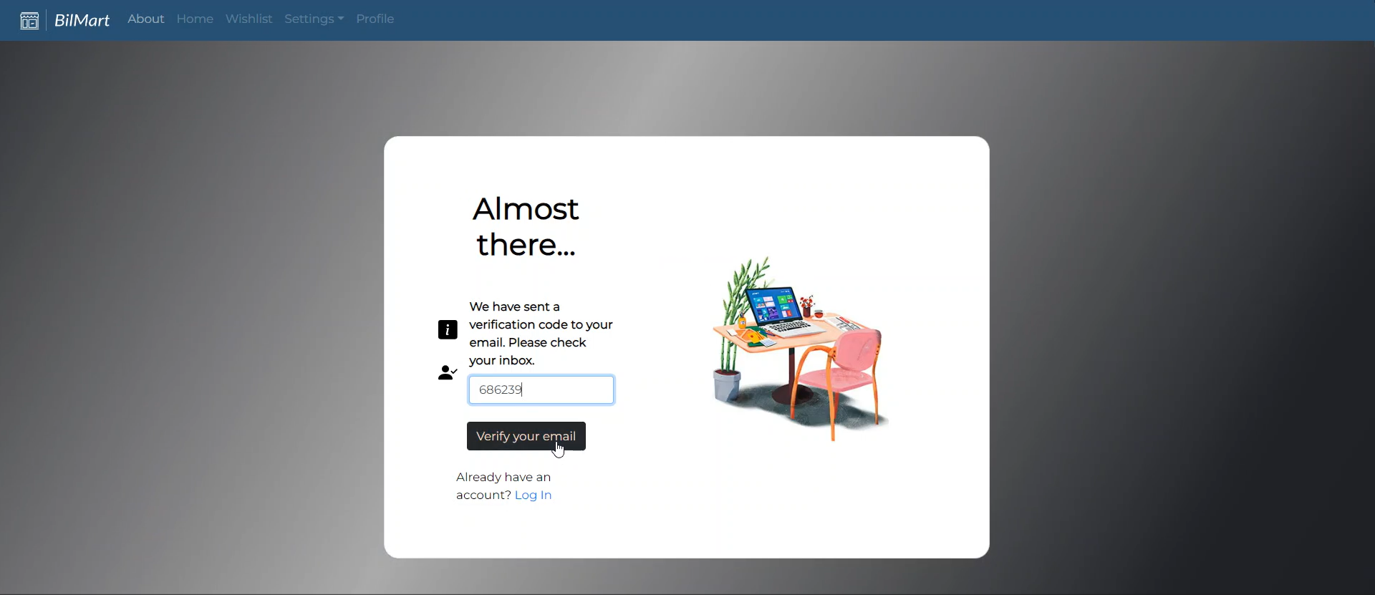

## D. Home page

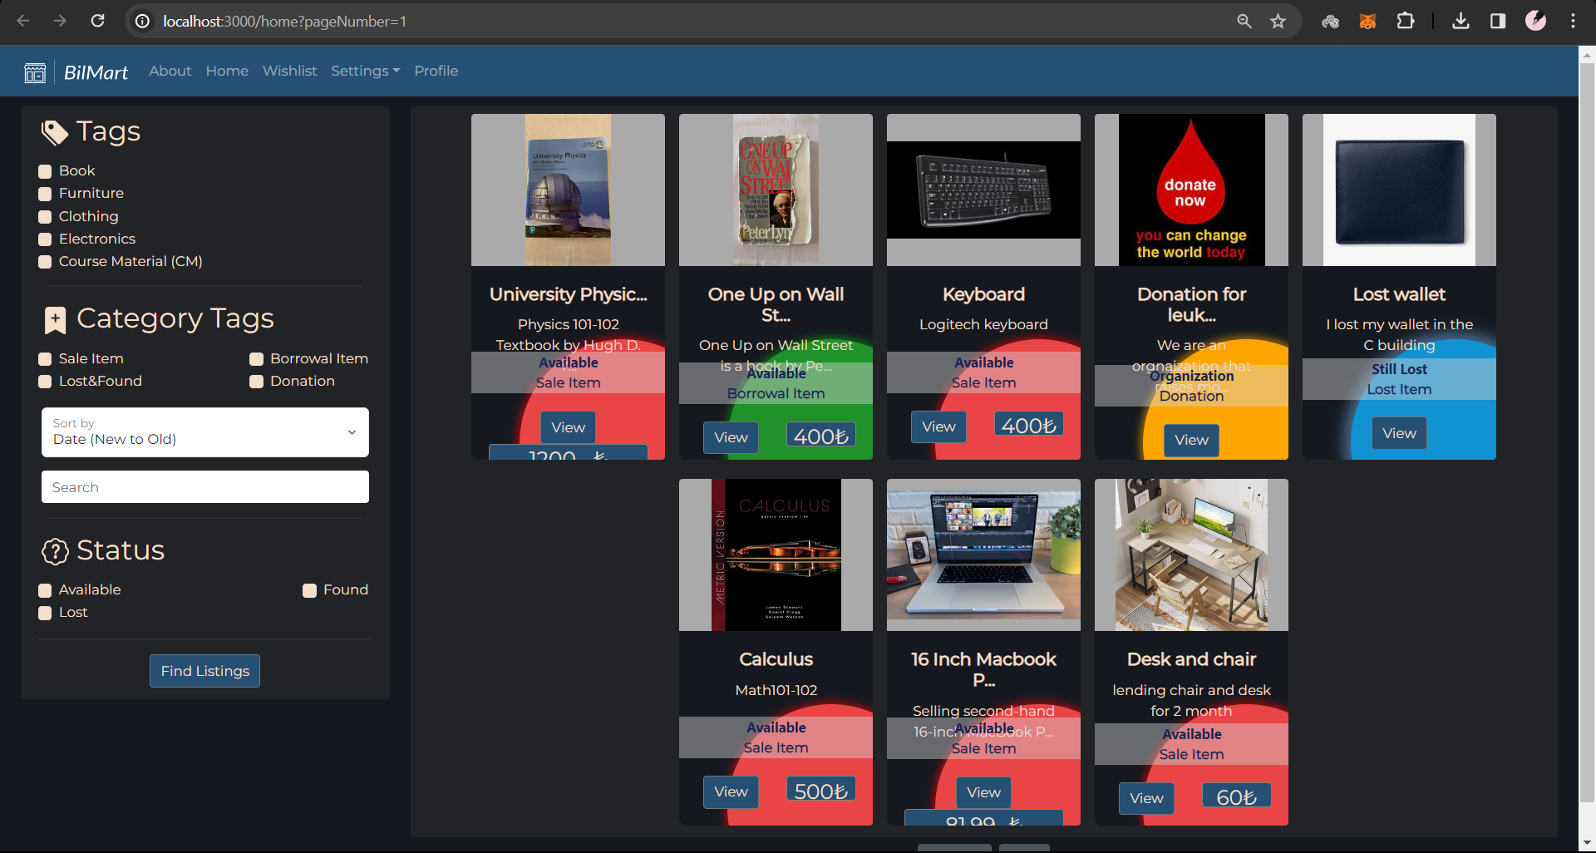

## E. View sale item with more than one picture

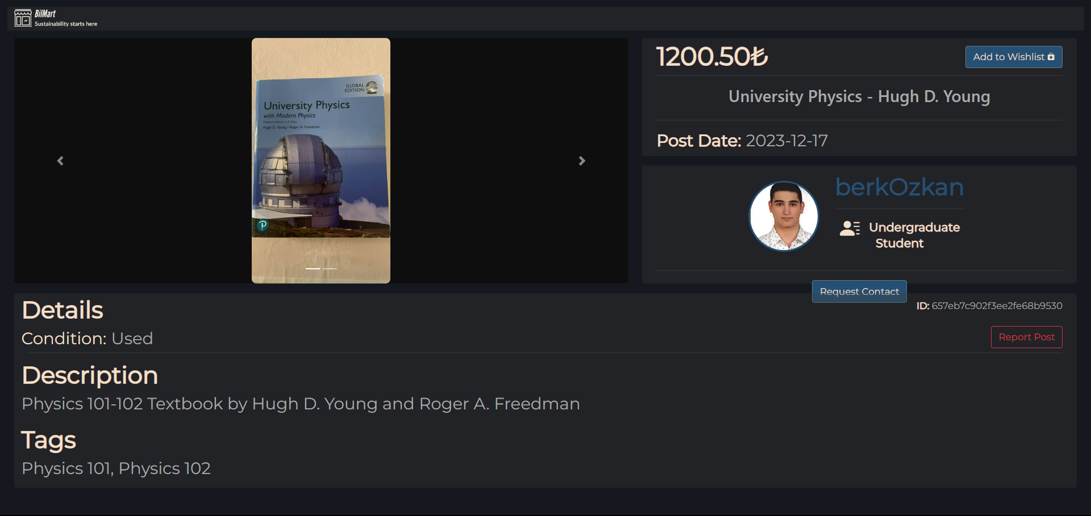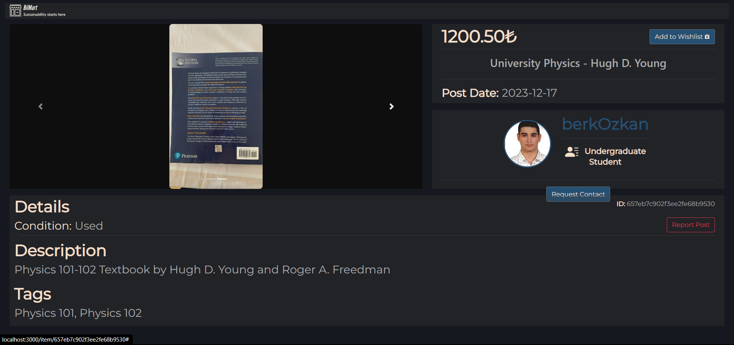

## F. View Donation Item

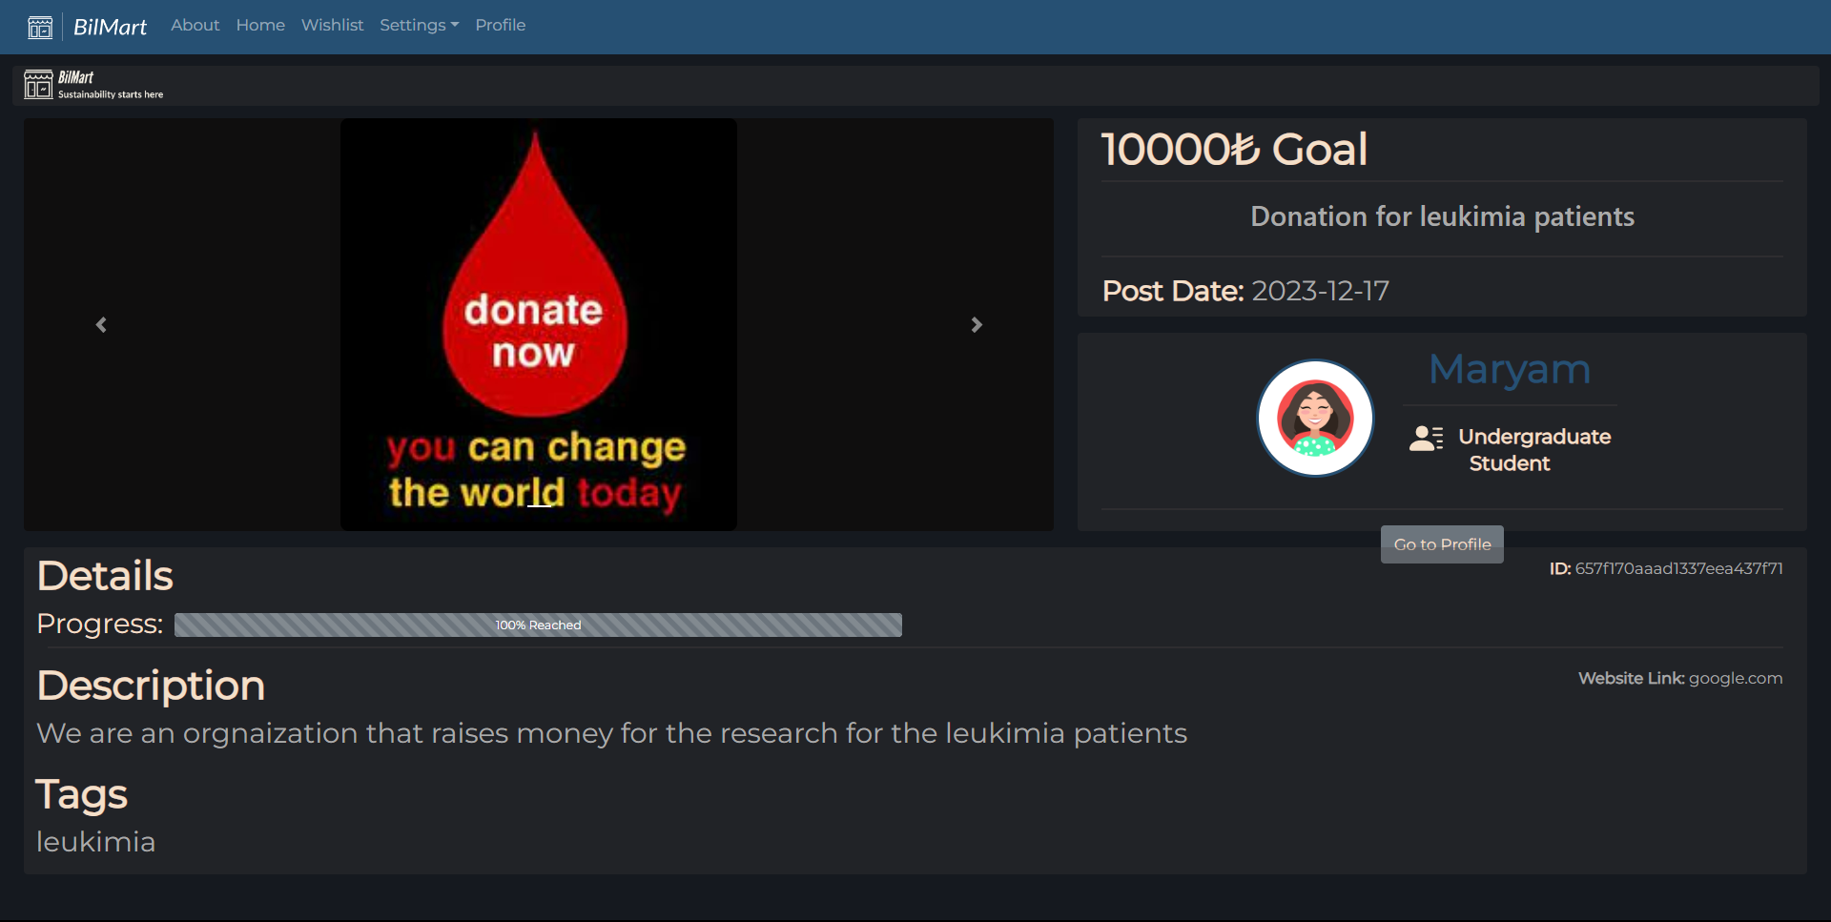

## G. View Borrowal item

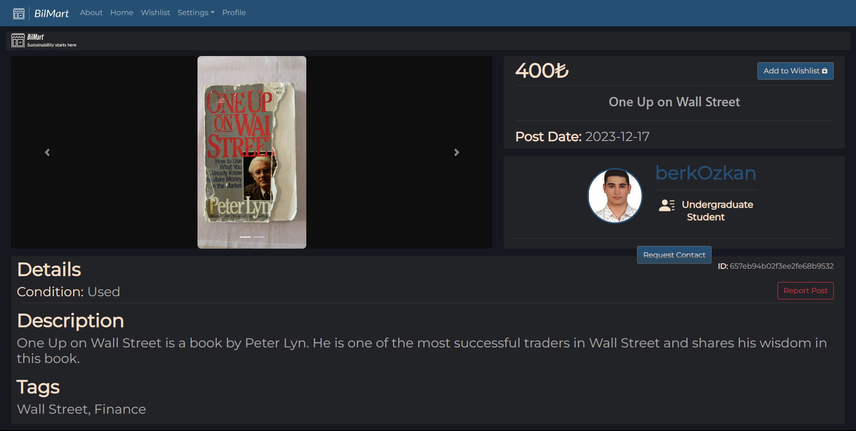

## H. View Lost item

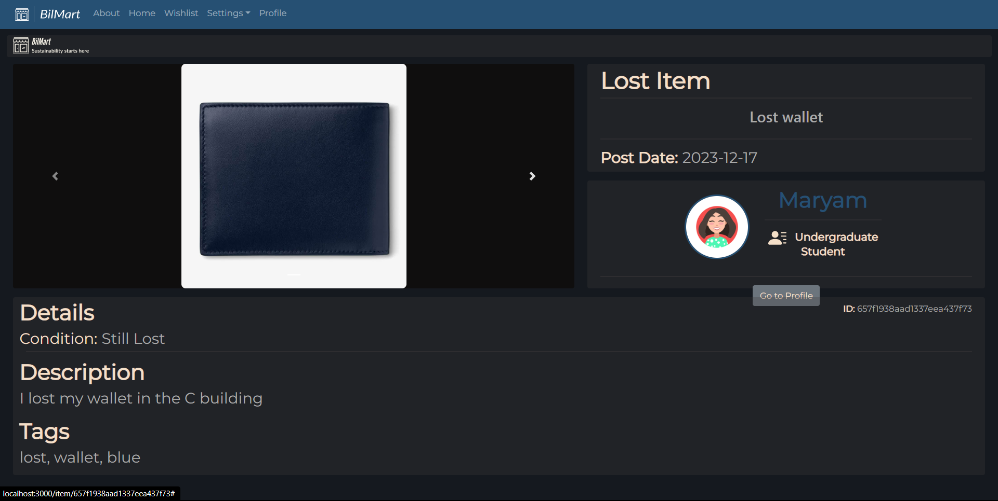

## I. Classification bar

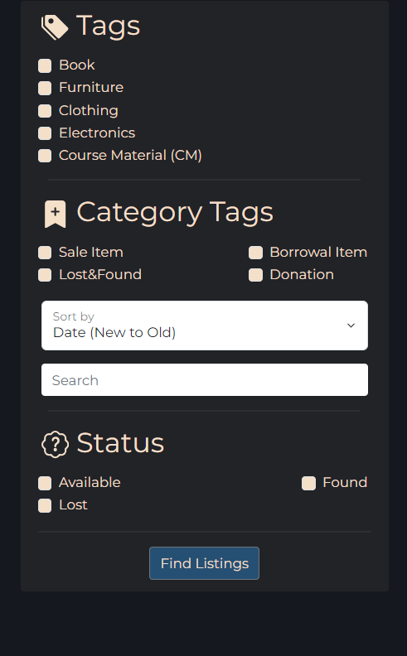

## J. Navigate panel

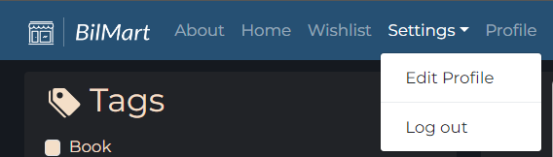

## K. About page

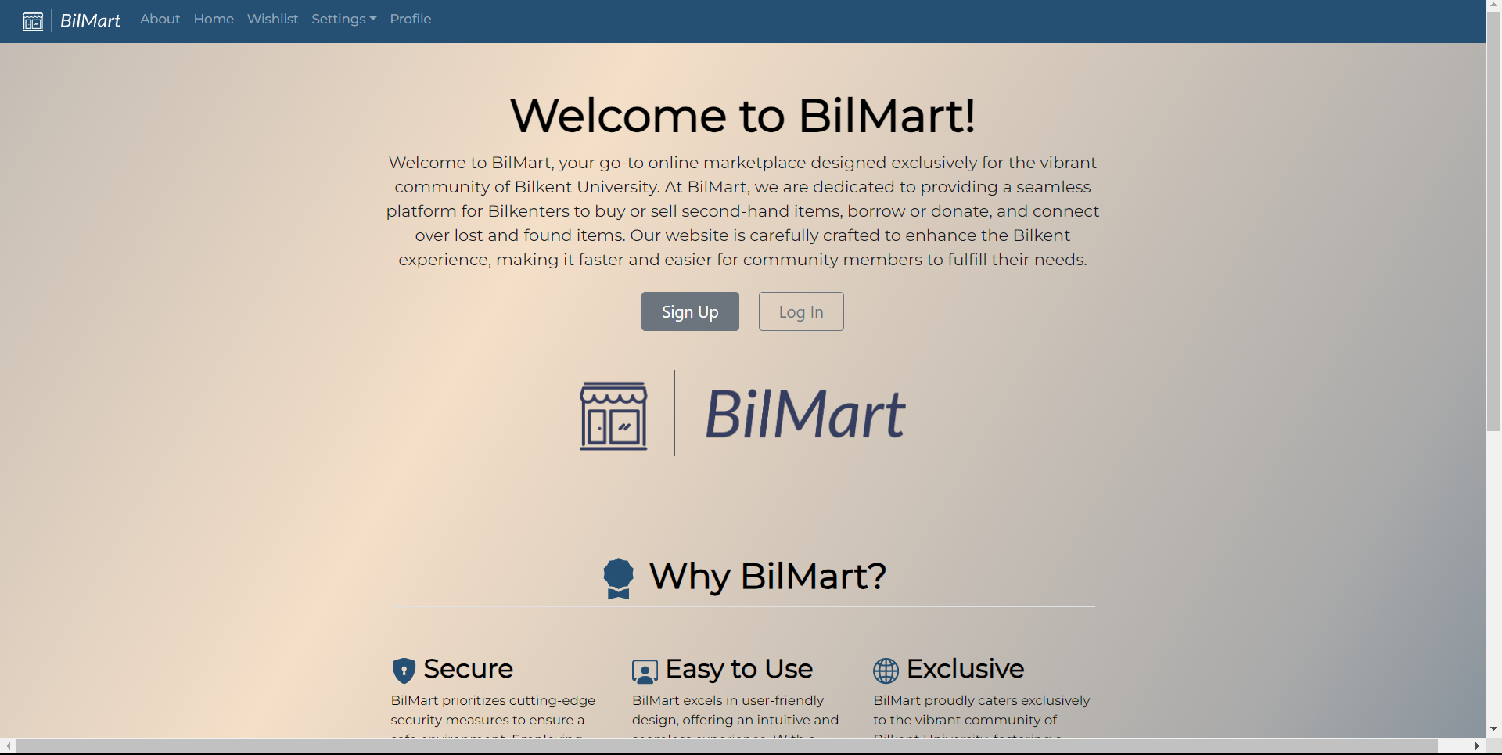

## L. Profile page

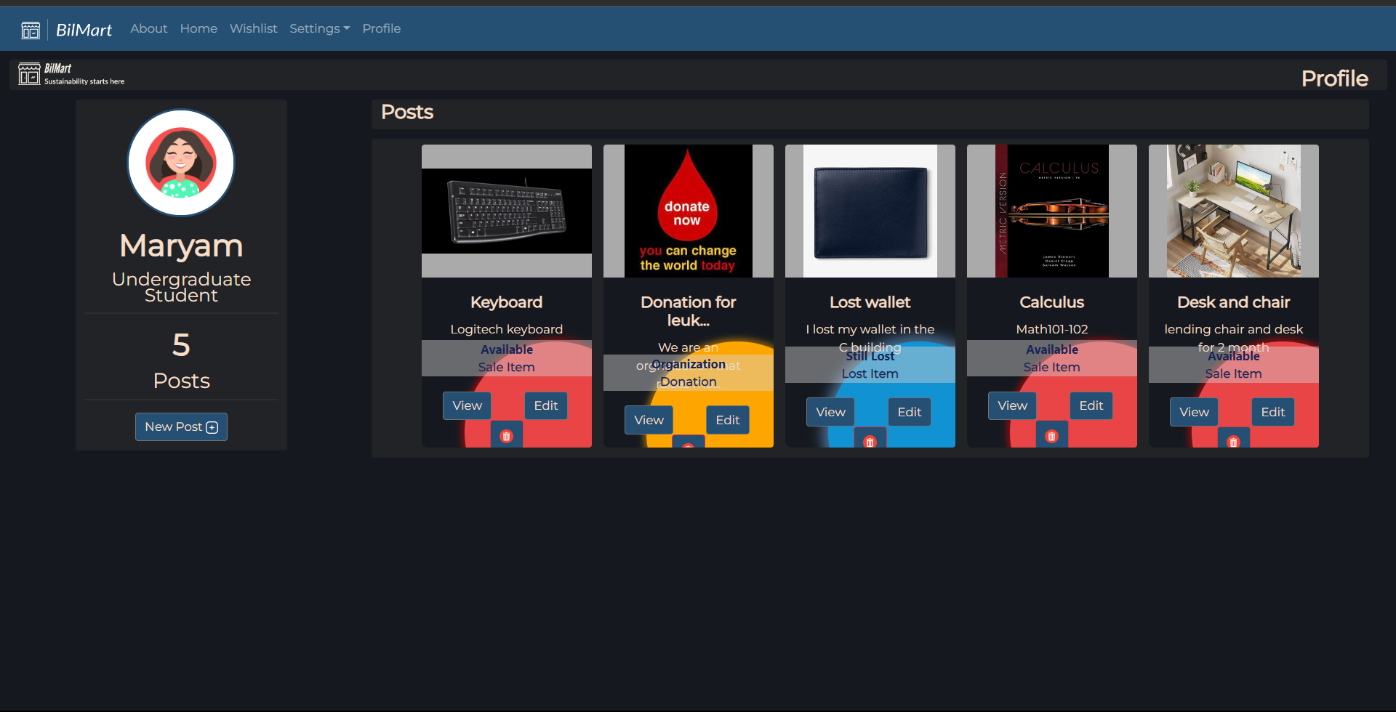

## M. Edit profile

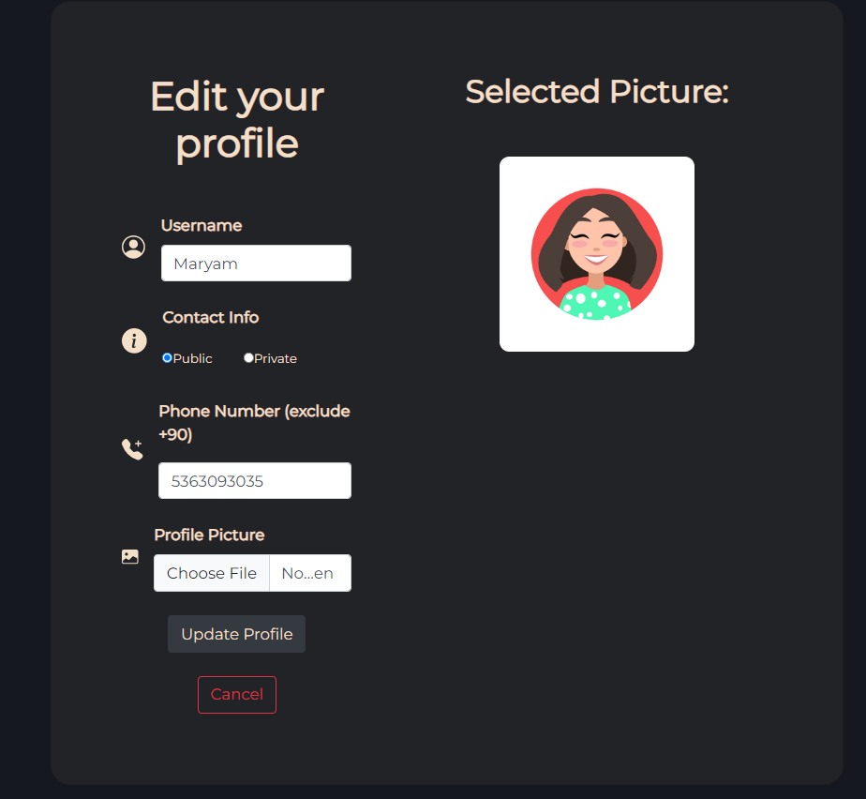

## N. Create a post

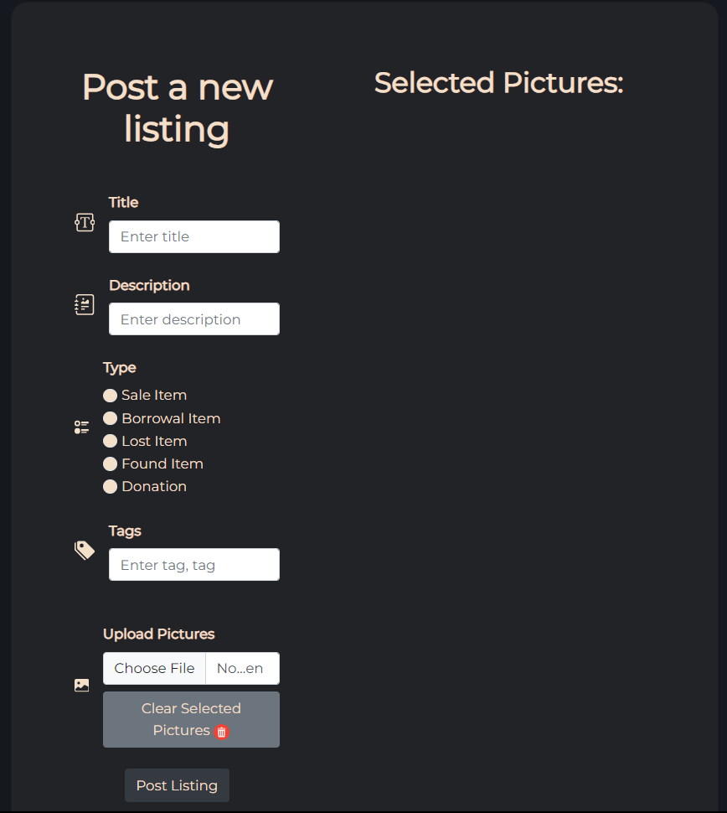

## O. Edit Post

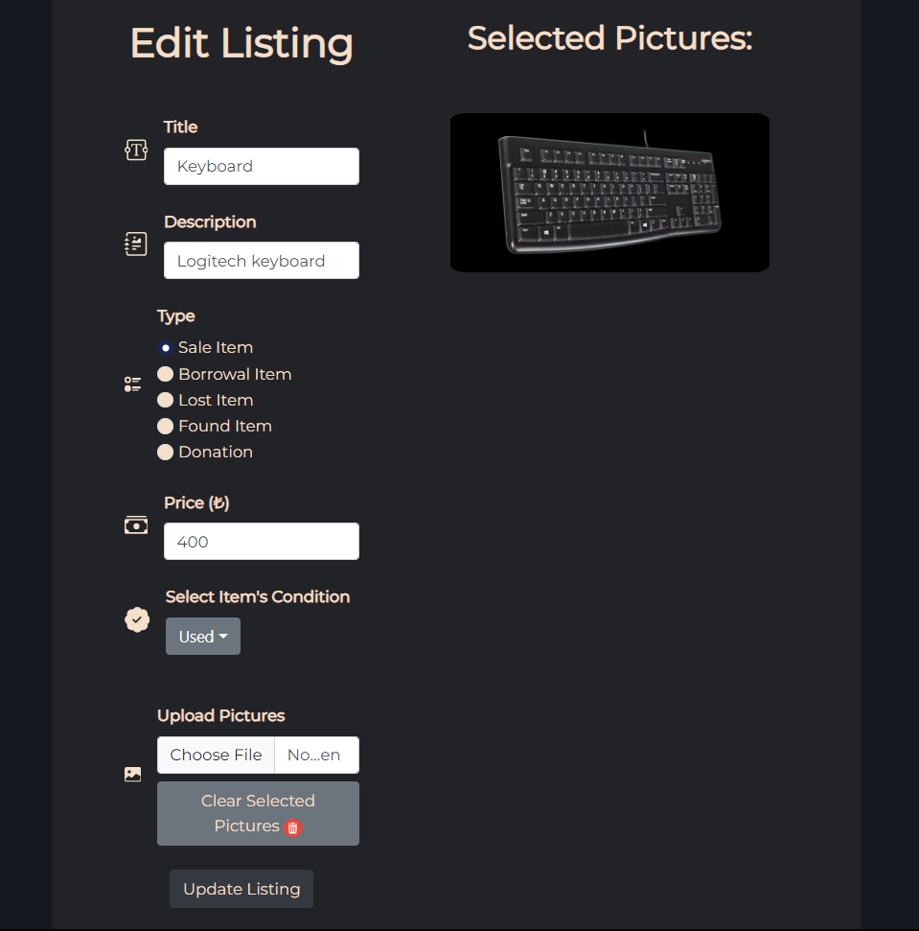

## P. Wishlist page

